https://hero-logistic-update.netlify.app/company-admin/drivers - Gender Button is not working

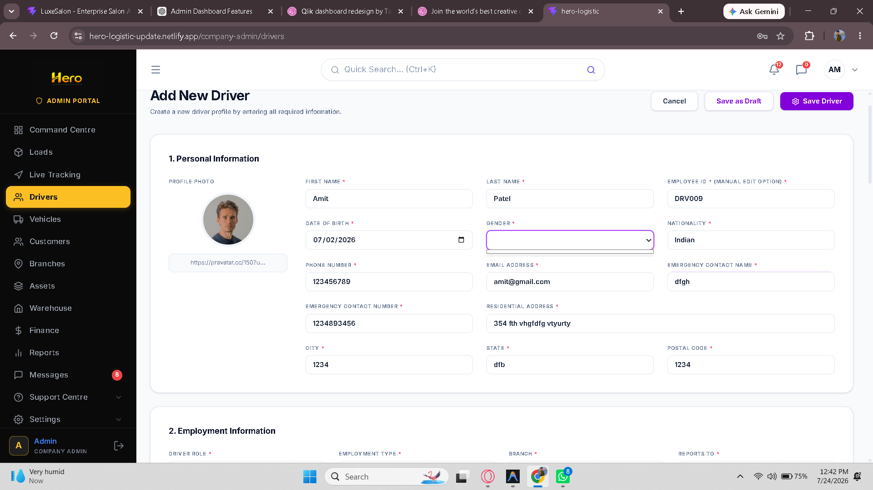

https://hero-logistic-update.netlify.app/company-admin/loads - does Not add and edit stops
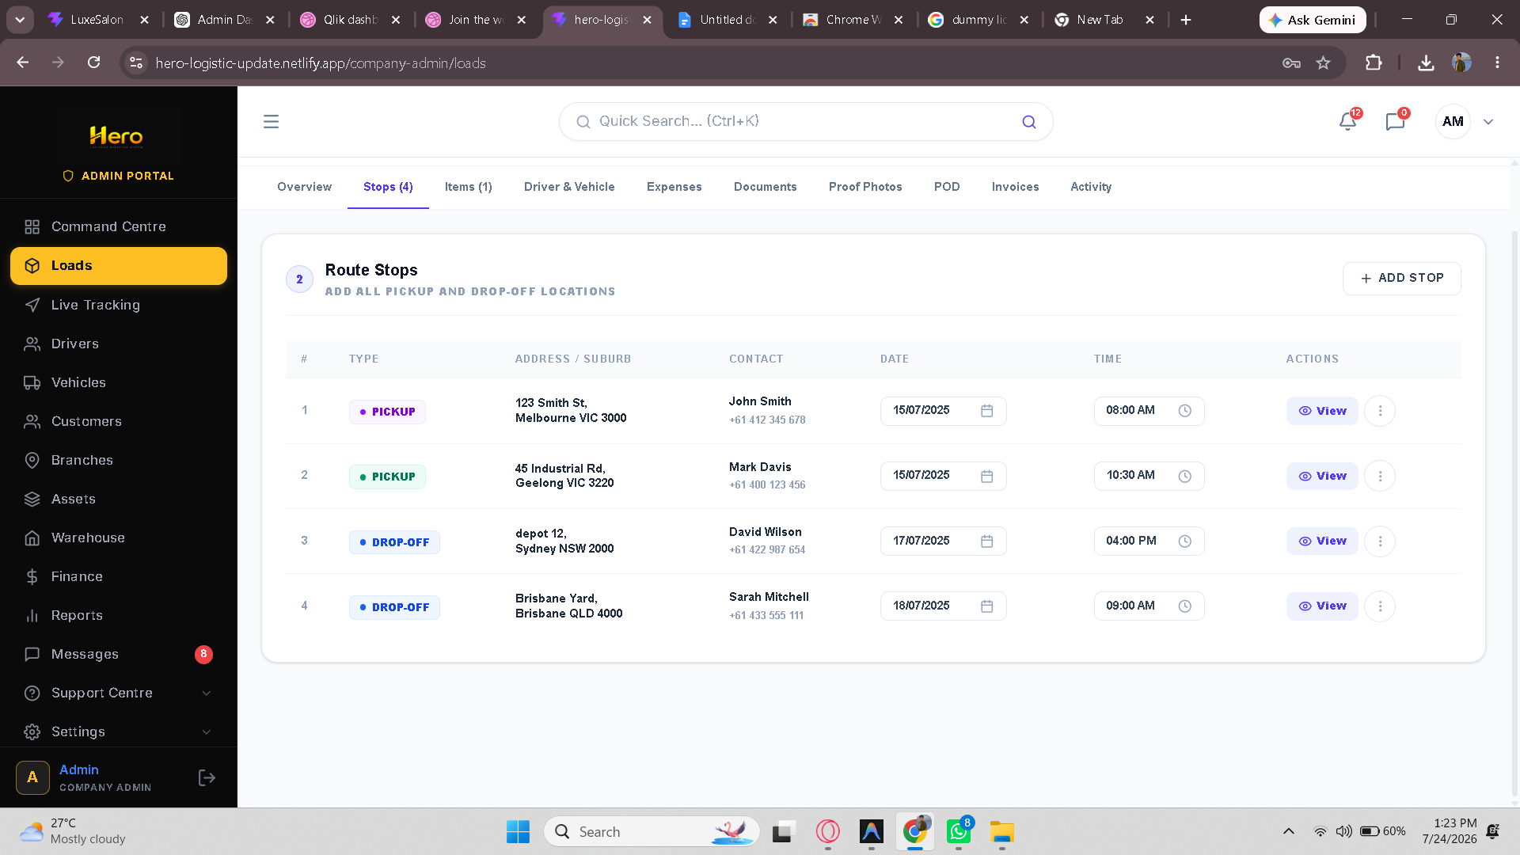

https://hero-logistic-update.netlify.app/company-admin/loads - does not add expense & upload receipt
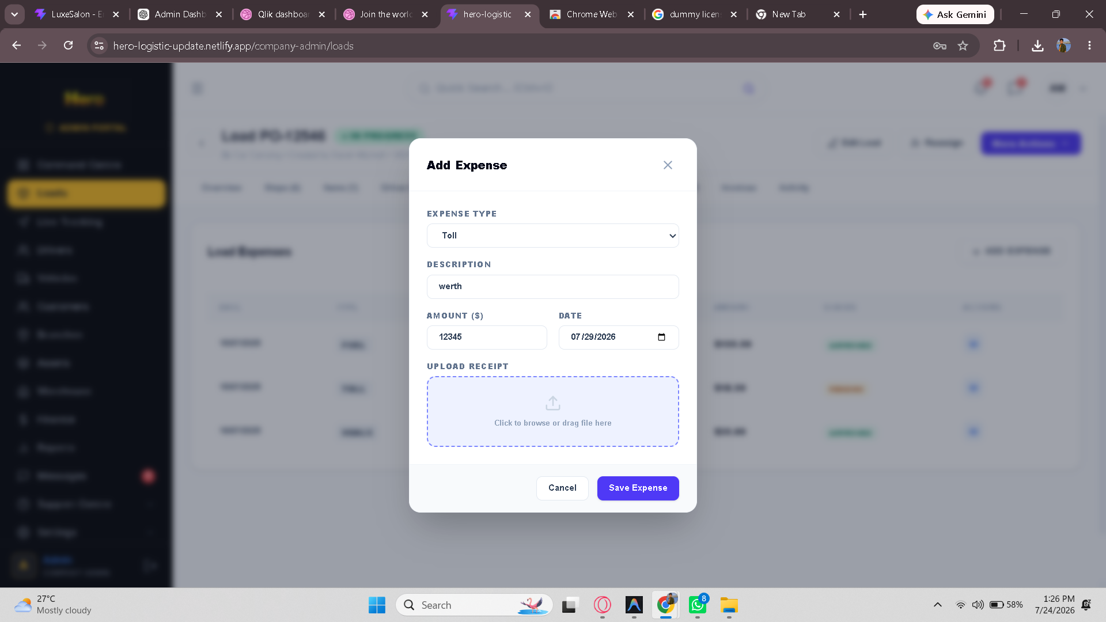
https://hero-logistic-update.netlify.app/company-admin/loads - upload documents is not working in documents menu
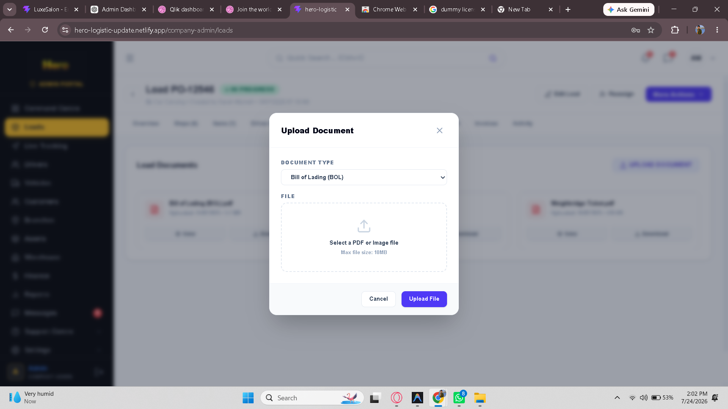

https://hero-logistic-update.netlify.app/company-admin/drivers - driver does not saved and edit
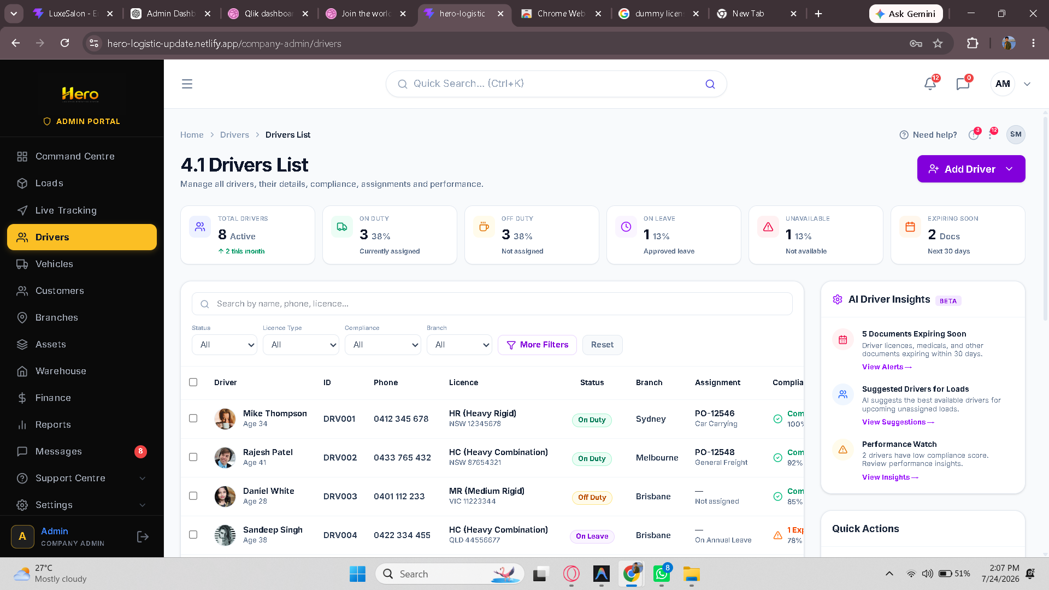

https://hero-logistic-update.netlify.app/company-admin/vehicles - filter is not working and also add and edit vehicle is not working and calender inputs are not working
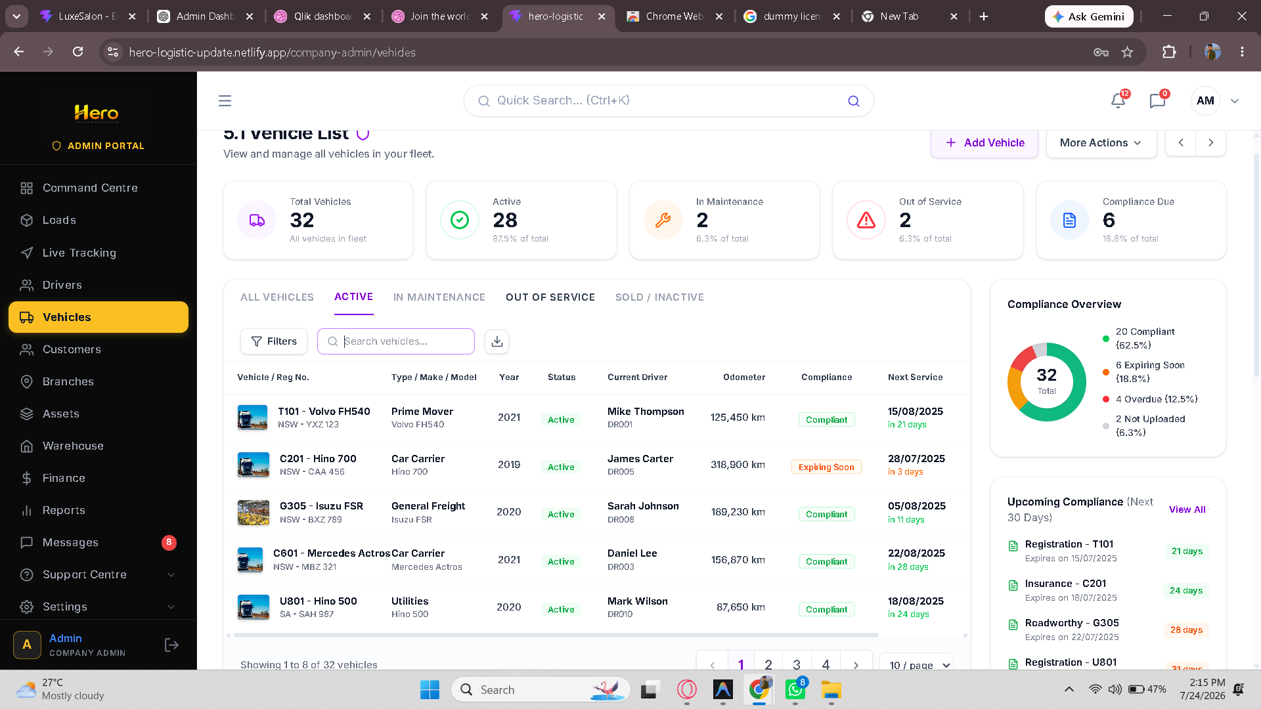

https://hero-logistic-update.netlify.app/company-admin/customers - customer menu
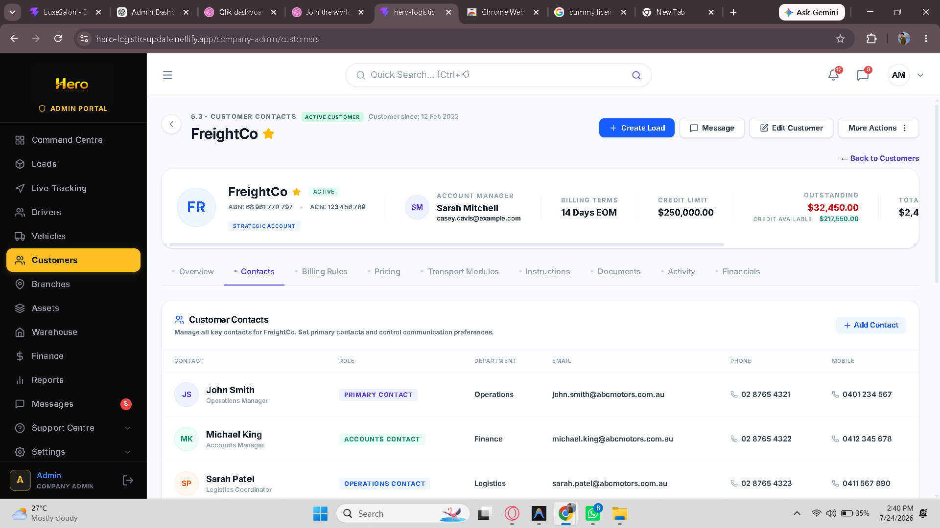

https://hero-logistic-update.netlify.app/company-admin/branches - does not add branches
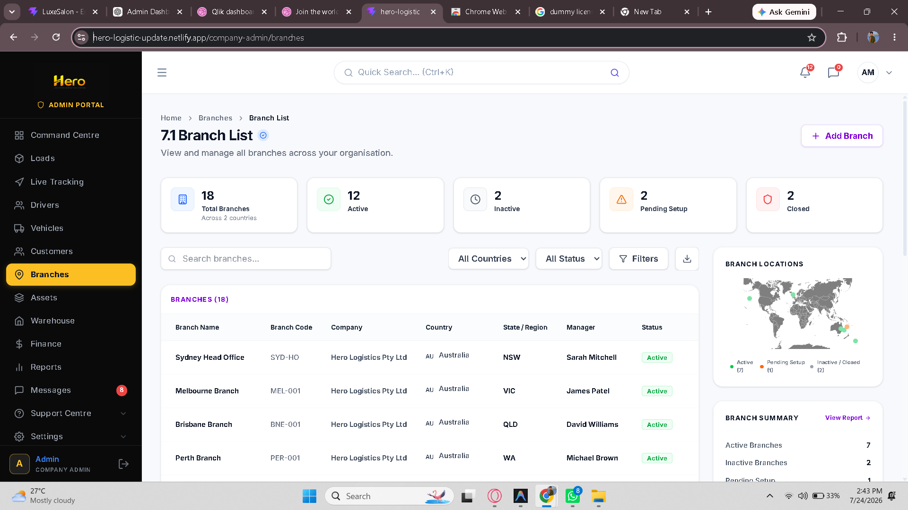

https://hero-logistic-update.netlify.app/company-admin/assets/new - does not add assets
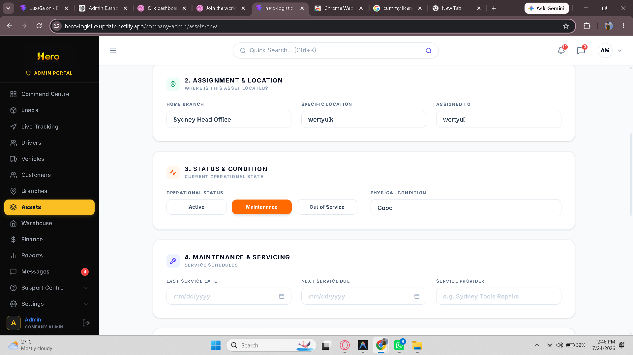

https://hero-logistic-update.netlify.app/company-admin/warehouse - filter and add warehouse is not working
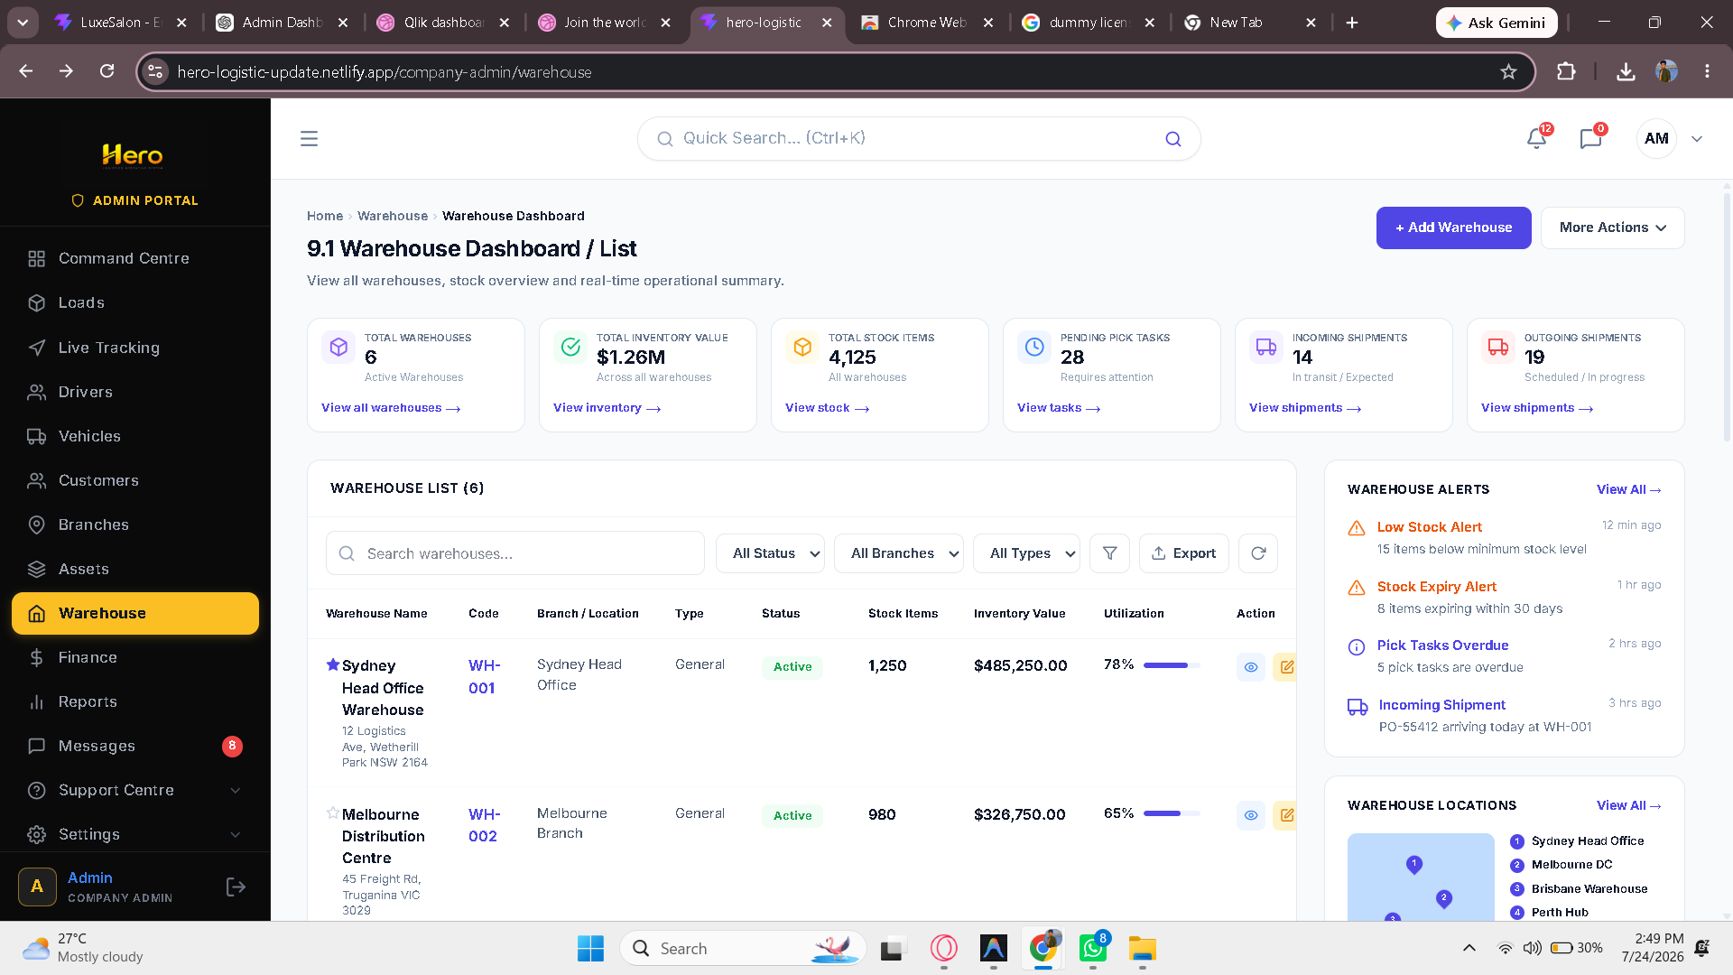

https://hero-logistic-update.netlify.app/company-admin/my-profile - does not update profile

